System Requirements

Before downloading and installing Android Studio, the following requirements are essential.

* Operating System Version - Microsoft Windows 7/8/10 (32-bit or 64-bit).
* Random Access Memory (RAM) - Minimum 4 GB RAM and 8 GB RAM recommended.
* Free Disk Space - Minimum 4 GB and 8 GB recommended.
* Minimum Required JDK Version - Java Development Kit (JDK) 8.
* Minimum Screen Resolution - 1280 * 800.resolution

Download and Install Android Studio

**Step 1**

To download the Android Studio, visit the official [Android Studio](https://developer.android.com/studio/) website in your web browser.

**Step 2**

Click on the "Download Android Studio" option.

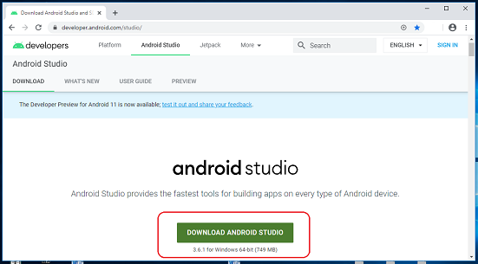

**Step 3**

Double click on the downloaded "Android Studio-ide.exe" file.

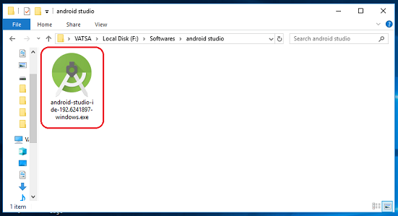

**Step 4**

"Android Studio Setup" will appear on the screen and click "Next" to proceed.

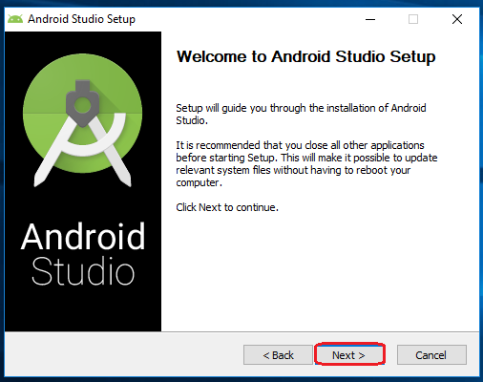

**Step 5**

Select the components that you want to install and click on the "Next" button.

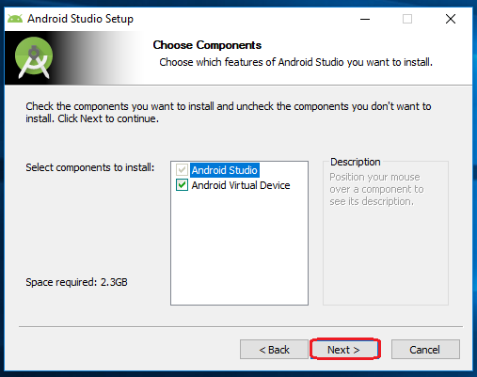

**Step 6**

Now, browse the location where you want to install the Android Studio and click "Next" to proceed.

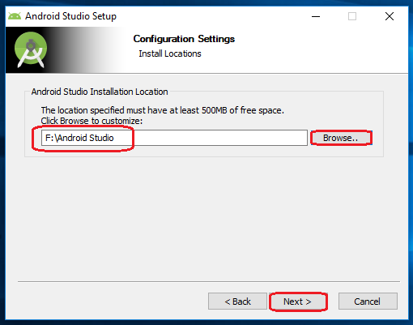

**Step 7**

Choose a start menu folder for the "Android Studio" shortcut and click the "Install" button to proceed.

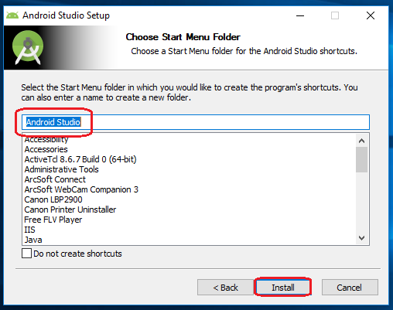

**Step 8**

After the successful completion of the installation, click on the "Next" button.

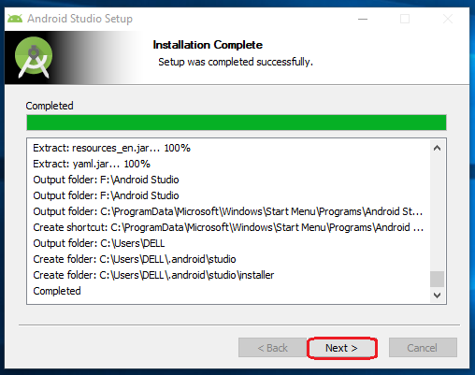

**Step 9**

Click on the "Finish" button to proceed.

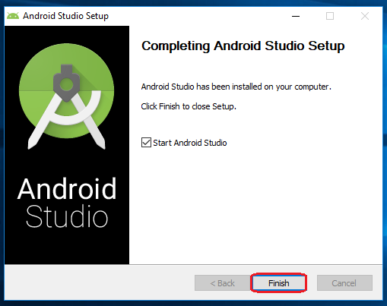

Now, your Android studio welcome screen will appear on the screen.

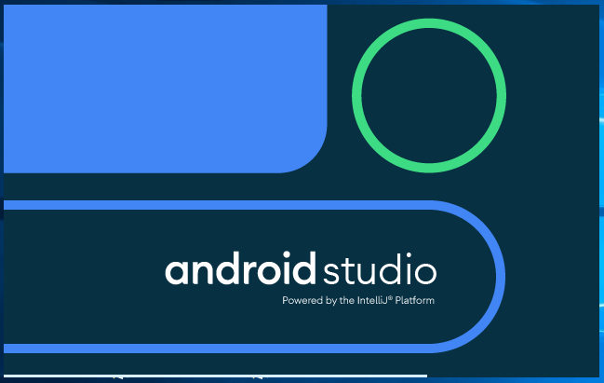

Android Studio Setup Configuration

**Step 10**

"Android Studio Setup Wizard" will appear on the screen with the welcome wizard. Click on the "Next" button.

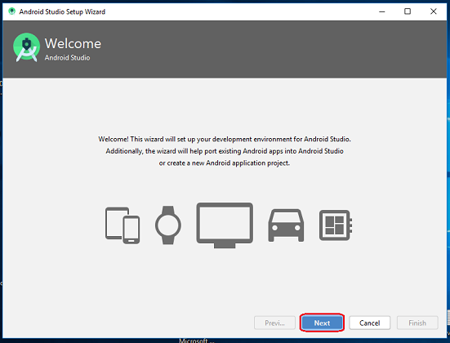

**Step 11**

Select (check) the "Standard" option if you are a beginner and do not have any idea about Android Studio. It will install the most common settings and options for you. Click "Next" to proceed.

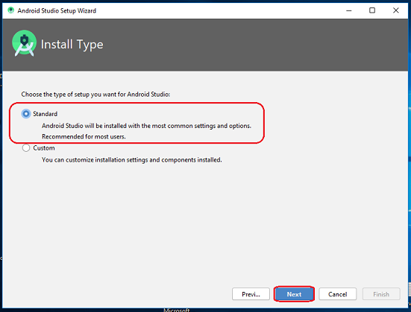

**Step 12**

Now, select the user interface theme as you want. (I prefer Dark theme (Dracula) that is most liked by the coders). Then, click on the "Next" button.

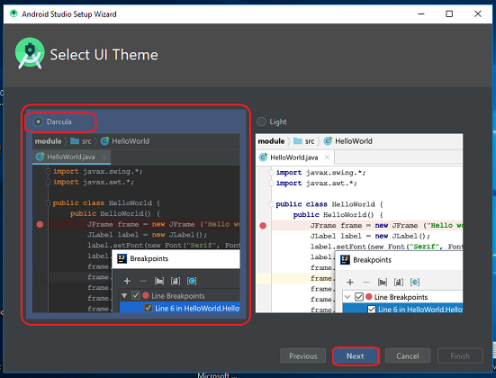

**Step 13**

Now, click on the "Finish" button to download all the SDK components.

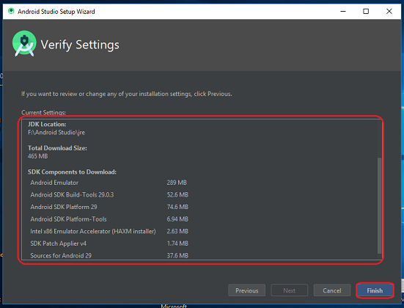

And, the downloading and installation process of components gets started.

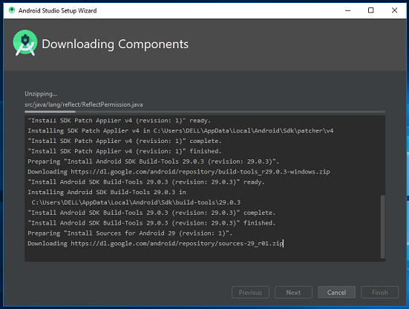

**Step 14**

After downloading all the necessary components, click on the "Finish" button.

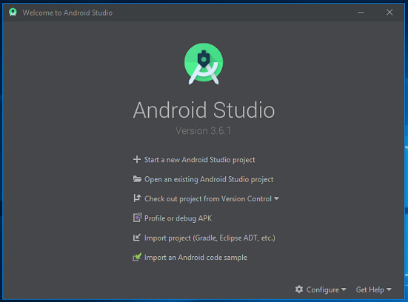

Congrats, your Android Studio has been successfully installed in your system and you can start a new Android studio project.